AutoEmail - PwC Oz AutoEMails
Tester: Tony Tasker
Date: 30th November 2016
Time: 14:30
PC/Server: TonyTasker-PC\SQL2014STD
Database: PwC_Oz_UnitTest
Works Summary: N/A
Works Order: N/A
Task: N/A
Notes: These tests were performed using Microsoft SQL Server Management Studio. Output to the Results and Messages Output Windows are used to determine the success of the tests. Also the receipt of emails.

Pre-Test Setup
No | Task | Tester | Pass | Notes
1 | In section CABS_AUTO_EMAIL_FUNCS_Trigger  Add DebugFlag=1  Ensure Enabled = 1 | TT
2 | In section CABS_AUTO_EMAIL_FUNCS_Trigger  Add DebugFlag=1  Ensure Enabled = 1 | TT
3 | In section AEFSWR  DebugSendDateTime=01/01/2016 00:00:01 | TT

Post-Test Setup
No | Task | Tester | Pass | Notes
1 | Reverse any Config Changes in X CABS Config | TT

Tests

Status Change Email - AEFSTC
No | Test | Tester | Pass | Notes
1 | Using the CABS Console locate a function to test with:  Using FA1TAGF on the 05/12/2016 | TT |  | Must be in the future
2 | Changed Status from Confirmed to Cancelled
3 | Process the AutoEmail  Run command the below command from MS SQL Server Management Studio  EXEC CABS_AUTO_EMAIL_FUNCS_SESS_CHECK | TT |  | Email delivered as per Figure 1
4 | Changed Status from Cancelled to Provisional
5 | Process the AutoEmail  Run command the below command from MS SQL Server Management Studio  EXEC CABS_AUTO_EMAIL_FUNCS_SESS_CHECK | TT |  | Email delivered as per Figure 2
6 | Changed Status from Provisional to Off Booking
7 | Process the AutoEmail  Run command the below command from MS SQL Server Management Studio  EXEC CABS_AUTO_EMAIL_FUNCS_SESS_CHECK | TT |  | Email delivered as per Figure 3
8 | Changed Status from Off Booking to Confirmed
9 | Process the AutoEmail  Run command the below command from MS SQL Server Management Studio  EXEC CABS_AUTO_EMAIL_FUNCS_SESS_CHECK | TT |  | Email delivered as per Figure 4

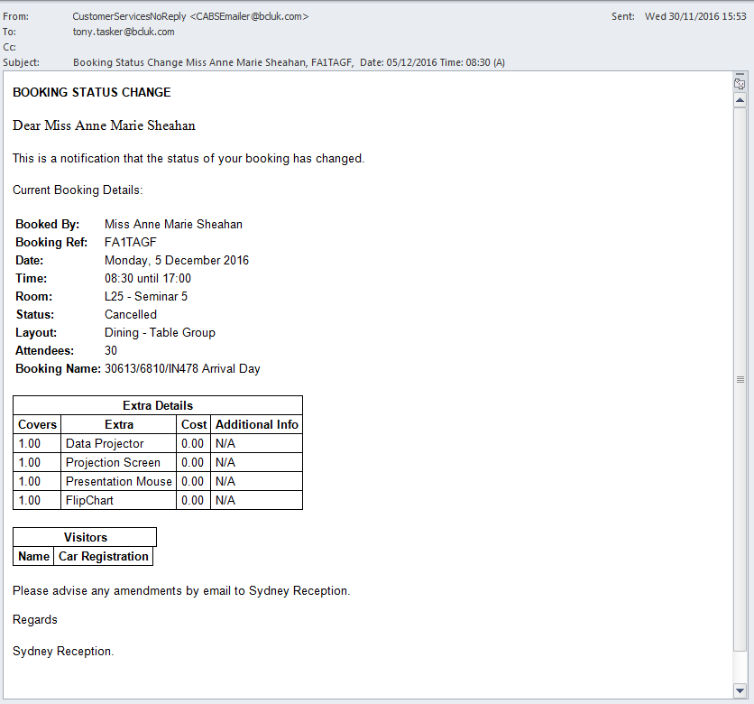
Figure 1 – Status Change Email – Confirmed to Cancelled
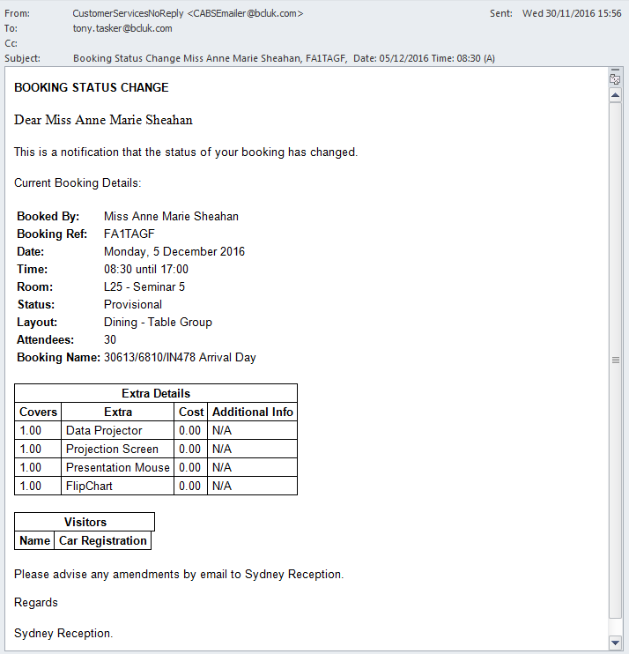
Figure 2 - Status Change Email - Cancelled to Provisional
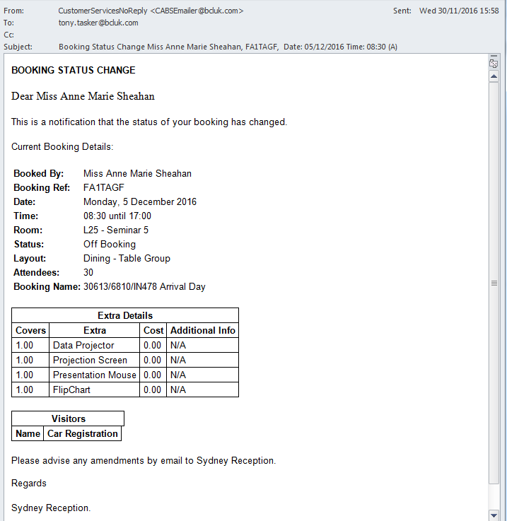
Figure 3 - Status Change Email - Provisional to Off Booking

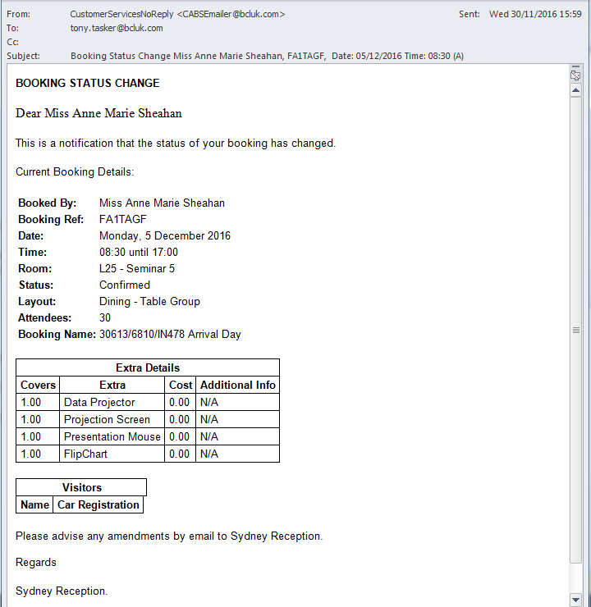
Figure 4 - Status Change Email - Off Booking to Confirmed

Summary Weekly Reminder Email - AEFSWR
No | Test | Tester | Pass | Notes
1 | Run command the below command from MS SQL Server Management Studio  UPDATE AEF_LINK SET AEFL_SENT = 0 WHERE AEFL_FREF = 'FFFFFFD' | TT |  | Will use the following settings in section AEFSWR to determine window in which confirmed functions are to be included.  ReportDurationInDays=7  ReportStartFromNowInDays=7
2 | Run command the below command from MS SQL Server Management Studio  SELECT * FROM vw_AEFLink | TT |  | For Email Template AEFSWR:  AEFL_CanSend should be 1,  AEFL_Sent should be 0,  SessionSendable should be 1,  Sendable should be 1,  MatchCriteria should be 1
3 | Process the AutoEmail  EXEC CABS_AUTO_EMAIL_FUNCS_SESS_CHECK | TT |  | Stored procedure executed successfully as per Figure 5  Emails are generated per Site location, per booker.  This test generated just under 300 emails  It is noted that there are no Booker Email addresses in the database.

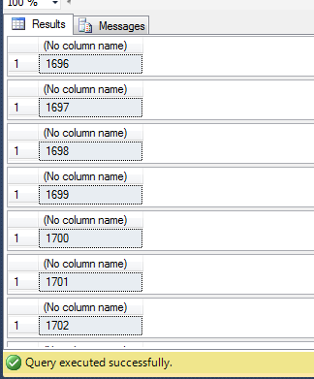
Figure 5 – Autoemail Code Executed without Error

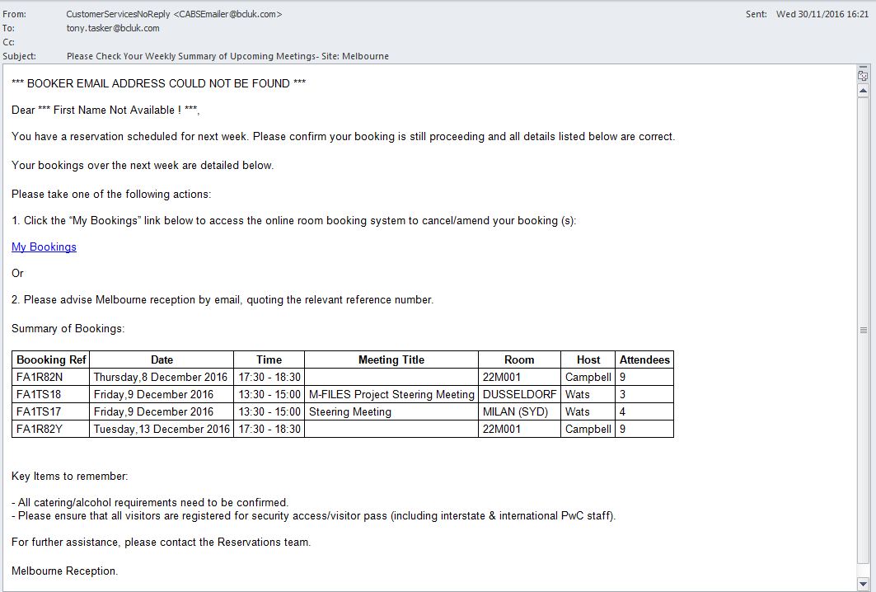
Figure 6 - Example Weekly Summary Email

Daily Reminder Email - AEFDRM
No | Test | Tester | Pass | Notes
1 | Using CABS Console, edit the Frequency setting in section AEFDRM and change it from  Frequency=D:3;H:0;M:0;W:1;L:B4;  To  Frequency=D:0;H:0;M:1;W:1;L:CR; | TT |  | This will enable changes to a booking to be sent now.
2 | Using the CABS Console locate a function to test with:  Using FA1RIKB on the 05/12/2016  Change the booking in some way | TT
3 | Run command the below command from MS SQL Server Management Studio  SELECT * FROM vw_AEFLink |  |  | For Email Template AEFDRM:  AEFL_CanSend should be 1,  AEFL_Sent should be 0,  SessionSendable should be 1,  Sendable should be 1,  MatchCriteria should be 1
4 | Process the AutoEmail  EXEC CABS_AUTO_EMAIL_FUNCS_SESS_CHECK | TT |  | Email delivered as per Figure 7
5 | Using CABS Console, edit the Frequency setting in section AEFDRM and change it from  Frequency=D:0;H:0;M:1;W:1;L:CR;  To  Frequency=D:3;H:0;M:0;W:1;L:B4; | TT

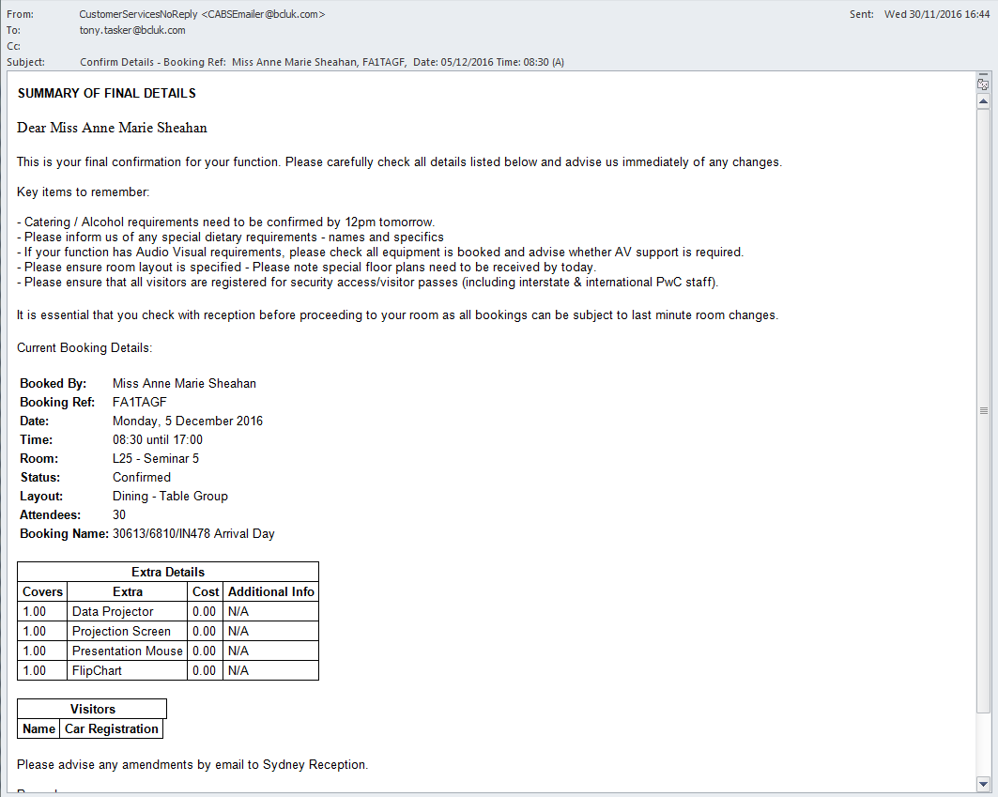
Figure 7 – Example Daily Reminder Email

